Presidents Pontifications: November 2017

Club Activity: Plenty happening at most clubs now with Club Championships, Invitational Events, Traveller Series kicking off and breeze starting to kick in.
Nedlands is a hive of activity with 11 boats seen racing plus the odd visitor. Some training was conducted on Spinnaker work last weekend and as more confidence and miles in the boats are completed I’m sure the NYC fleet will get more and more competitive.
Esperance looks like it’s had a mix of conditions and boats out racing. Good to see some new faces and we wish EBYC good luck with the upcoming Peli States.
SOPYC is perhaps the hardest fought fleet for placings each week. The boys on Going Gonzo setting the pace but not having it all their own way. It was good to see SOPYC send a couple of representatives to Maylands.
East Freo has been quiet but we did see Boogie Nights back on the water. The trick is getting everyone sailing at the same time it seems. Baby steps, but a rebuild is under way.

Rob Webb Traveller Series: The Mud Classic was run a couple weekends ago in a flukey Easterly. One Too Many was first home but in second was the surprise…with Consuming Passion coming home strong to pip Flashin Ya Nemo. Always god fun at Maylands and very hospitable too.

- The next event is SATURDAY 25th at MANDURAH OFFSHORE SAILING CLUB: Racing Starts at 1.45pm. Gates open from 10.30am. Up to 3 short races.

- The Port Bouvard CRAB CLASSIC is SATURDAY 2nd DECEMBER. Morning and afternoon races so keep an eye out for details from your delegates or on the FB Page.

- The EFYC Rumble in the Reach is SATURDAY 20th JANUARY: 3 Races in the morning then a long table lunch get together so we can watch the PM racing

Boats for Sale: These are the boats I am aware of for sale. For any details and contacts speak to your club delegates.

3105 Shockwave (at SOPYC) $3000
3189 Firefly $5000
2872 Chunky Custard (at NYC) $1500
3191 The Pest (at EFYC) $12000
3097 Flying Dutchman (at EBYC)
3051 Vigilant (at EFYC) $3000
3057 Perentie (at NYC) $4000

We have had some enquires re boats from PBYC so if your keen to sell perhaps send them some details or fliers.

Association Vacancies: Publicity Officer

41st Nationals: At this stage it looks like our sole representative will be 3196 One Too Many. I will keep you all updated on the event via the Facebook Page National 125 WA Association

Messages: As some may have heard our Treasurer, and Life Member, Gavin Jones has had a scare with his health last weekend so we wish him a speedy recovery and hope to see him 125ing again soon.

Cheers
Snodge
3196 One Too Many

Ryan and Nic on 3195 “Going Gonzo” at SOPYC

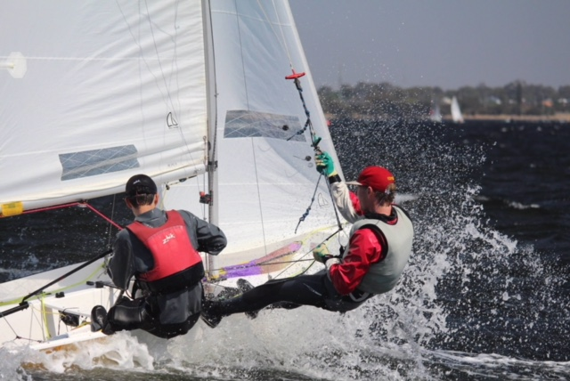

Spinnaker Training at NYC

